Monster Mash
Halloween Dance
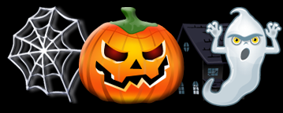

Date: Saturday October 27,2012
Time: 7:00 p.m. – 9:30 p.m.,
Where: CLASS Building,
125 Dufferin Street South,
Alliston, Ontario
Admission: $5.00 per family
Refreshments: Pot Luck snacks or finger foods,
beverages will be provided.

This is a social event for students with special needs,
from grades 7 to 12, and their parents/caregivers.
Please R.S.V.P. by October 22, 2012 .
Andrea Keogh at 705-718-7215,
or Debra Waylen at 705-250-0149

Dress Code: Halloween Costume or Halloween Colours

Come have a Spook-tacular time!!

